A

Project Report

On

**Automatic Parking Space Detection System**

Submitted in partial fulfilment of the requirement for the Vth semester

**Bachelor of Computer Science**

By

**MANOJ NATH GOSWAMI**

Under the Guidance of

**Mr. Devesh Pandey**

**Assistant Professor**

**Department of CSE**



# DEPARTMENT OF COMPUTER SCIENCE & ENGINEERING GRAPHIC ERA HILL UNIVERSITY, BHIMTAL CAMPUS

**SATTAL ROAD, P.O. BHOWALI, DISTRICT- NAINITAL-263132**

**2023- 2024**

## STUDENT’S DECLARATION

I, **Manoj Nath Goswami** here by declare the work, which is being presented in the project, entitled “**Automatic Parking Space Detection System**” in partial fulfilment of the requirement for the award of the degree **B.Tech** in the session **2023-2024**, is an authentic record of my own work carried out under the supervision of “**Mr. Devesh Pandey”, Assistant Professor, Department of CSE, Graphic Era Hill University, Bhimtal.** The matter embodied in this project has not been submitted by us for the award of any other degree.

Date:

Manoj Nath Goswami

2161228

**CERTIFICATE**

The project report entitled “**Automatic Parking Space Detection System**” being submitted by **Manoj Nath Goswami** to Graphic Era Hill University Bhimtal Campus for the award of bonafide work carried out by him. He has worked under my guidance and supervision and fulfilled the requirement for the submission of report.

**(Mr. Devesh Pandey) (Dr. Ankur Bisht)**

**Project Guide (HOD, CSE Dept.)**

**ACKNOWLEDGEMENT**

I take immense pleasure in thanking Honourable **“Mr Devesh Pandey”** (**Assistant** **Professor,** **CSE, GEHU Bhimtal Campus**) to permit me and carry out this project work with his excellent and optimistic supervision. This has all been possible due to his novel inspiration, able guidance and useful suggestions that helped me to develop as a creative researcher and complete the research work, in time.

Words are inadequate in offering my thanks to GOD for providing me everything that we need. We again want to extend thanks to our President **“Prof. (Dr.) Kamal Ghanshala”** for providing us all infrastructure and facilities to work in need without which this work could not be possible.

Many thanks to Professor **“Dr. Manoj Chandra Lohani”** (Director Gehu Bhimtal),other faculties for their insightful comments, constructive suggestions, valuable advice, and time in reviewing this thesis.

Finally, yet importantly, we would like to express my heartiest thanks to our beloved parents, for their moral support, affection and blessings. We would also like to pay our sincere thanks to all our friends and well-wishers for their help and wishes for the successful completion of this research.

**Manoj Nath Goswami**

**TABLE OF CONTENTS**

ABSTRACT 6

1. **INTRODUCTION** 
   1. PROJECT AIMS AND OBJECTIVES **7**
   2. BACKGROUND OF PROJECT  **7**
   3. OPERATION ENVIRONMENT **7**
2. **SYSTEM ANALYSIS**
   1. SOFTWARE REQUIREMENT SPECIFICATION 8
   2. EXISTING VS PROPOSED 9
   3. SOFTWARE TOOL USED 9
3. **SYSTEM DESIGN**
   1. TABLE DESIGN 10
   2. DATA FLOW DIAGRAM’S 10
4. **SYSTEM IMPLEMENTATION**
   1. SCREEN SHOTS 11
5. **SYSTEM TESTING**
   1. UNIT TESTING 12
   2. INTEGRATION TESTING 12
6. **CONCLUSION & FUTURE SCOPE** 13
7. **REFERENCES** 14

**Abstract:**

Searching a suitable parking space in populated metropolitan city is extremely difficult for drivers. Serious traffic congestion may occur due to unavailable parking space. Automatic smart parking system is emerging field and attracted computer vision researchers to contribute in this arena of technology. In this paper, we have presented a vision based smart parking framework to assist the drivers in efficiently finding suitable parking slot and reserve it. Initially, we have segmented the parking area into blocks using calibration. Then, classify each block to identify car and intimate the driver about the status of parking either reserved or free. Now a day’s most of the parking areas are manually managed by human manpower and there is no automatic system to manage the parking area in an efficient way. There is great analogy that when a driver enters any of the parking lot he must look for some kind of information board that tells him about the status of the parking lot that whether it is fully occupied, partly occupied or vacant. Most of the times the drivers have to circle around the parking area in search of the free parking space. This kind of problem mostly occur in cities near the shopping malls, hospitals etc., where the number of vehicles is greater as compared to the parking spaces.

**CHAPTER 1**

**INTRODUCTION**

This chapter gives an overview about the aim, objectives, background and operation environment of the system.

**1.1 PROJECT AIMS AND OBJECTIVES**

### I am presenting a vision based smart parking framework to assist the drivers in efficiently finding suitable parking slot and reserve it.The project aimed to create a real-time parking space counter using computer vision.

### Customizable Parking Space Design.

### Real-time Monitoring.

### Integration Options.

### Enhanced Efficiency.

### 1.2 BACKGROUND OF PROJECT

Searching a suitable parking space in populated metropolitan city is extremely difficult for drivers. Serious traffic congestion may occur due to unavailable parking space. Automatic smart parking system is emerging field and attracted computer vision researchers to contribute in this arena of technology.

**1.3 OPERATION ENVIRONMENT**

|  |  |
| --- | --- |
| PROCESSOR | INTEL CORE PROCESSOR OR BETTER PERFORMANCE |
| OPERATING SYSTEM | WINDOWS VISTA, WINDOWS7, UBUNTU |
| MEMORY | 1GB RAM OR MORE |
| HARD DISK SPACE | MINIMUM 3GB FOR DATABASE USAGE FOR FUTURE |

**CHAPTER 2**

**SYSTEM ANALYSIS**

This chapter discusses the development process of the Automatic Parking Space Counter Detection System, focusing on the Software Requirement Specification (SRS) and a comparison between the existing manual parking management system and the proposed automated system.

* 1. **Software Requirement Specification**

**1.1.1 General Description**

**Product Description**: The Automatic Parking Space Counter Detection System is a Python-based machine learning project designed to automate the detection and counting of available parking spaces. It utilizes computer vision techniques to analyze images of parking lots and determine the status of individual parking spaces.

Problem Statement: Challenges in the existing manual parking management system include:

* Manual counting and monitoring of parking spaces.
* Inaccuracies in space availability due to human errors.
* Time-consuming and labor-intensive process.
* Lack of real-time information on parking space occupancy.

**1.2 System Objectives**

* Real-time Monitoring: Provide real-time information on parking space availability.
* Efficiency: Automate the process of counting and monitoring parking spaces.
* Accuracy: Reduce the likelihood of errors in determining space occupancy.
* Time-Saving: Offer a faster and more efficient method compared to manual monitoring.

1.3 **System Requirements**

1.3.1 **Non-Functional Requirements**

**Product Requirements:**

Efficiency Requirement: Implementing the Automatic Parking Space Counter Detection System will lead to faster and more accurate monitoring of parking spaces.

**Reliability Requirement**: The system must reliably detect and count parking spaces based on the machine learning algorithm.

**Usability Requirement**: The system should provide an easy-to-understand interface for users and administrators.

**Organizational Requirement Implementation Requirements:** The system will be implemented using Python and relevant machine learning libraries for computer vision.

**Delivery Requirements:** The entire system is expected to be delivered within a specified timeframe, with regular evaluations by the project guide.

1.3.2 **Functional Requirements**

1. Automated Parking Space Detection:
   * The system should identify parking spaces in a given image.
   * Determine whether a parking space is vacant or occupied.
2. Space Vacancy Detection:
   * Utilize machine learning algorithms for accurate detection.
   * Count and display the number of available parking spaces.
3. Real-time Updates:
   * Provide real-time updates on parking space availability.

2. **Software and Hardware Requirements**

2.1 **Software Requirements**

* Python: Utilize Python for coding and implementing machine learning algorithms.
* Machine Learning Libraries: Use relevant machine learning libraries for computer vision.

2.2 **Hardware Requirements**

* Processor: Implement a fast and reliable processor for efficient computation.
* Memory (RAM): Utilize sufficient RAM for quick data processing.

**3. Existing System**

In the traditional manual parking management system:

* Parking spaces are monitored and counted manually.
* Human errors may lead to inaccuracies.
* The process is time-consuming and labor-intensive.

**4. Proposed System**

The proposed Automatic Parking Space Counter Detection System:

* Automates the process using machine learning algorithms.
* Provides real-time and accurate information on parking space availability.
* Enhances efficiency and reduces manual effort.

**5. System Implementation**

**5.1 Machine Learning Algorithms**

The system will implement machine learning algorithms for:

* Image processing and feature extraction.
* Training the model to detect vacant and occupied parking spaces.

**5.2 SYSTEM BLOCK DIAGRAM**

**Parking Space**

Model

CCTV

Update free Space

**Detect Space**

**5.2 Data Collection**

Collect a dataset of parking lot images for training and testing the machine learning model.

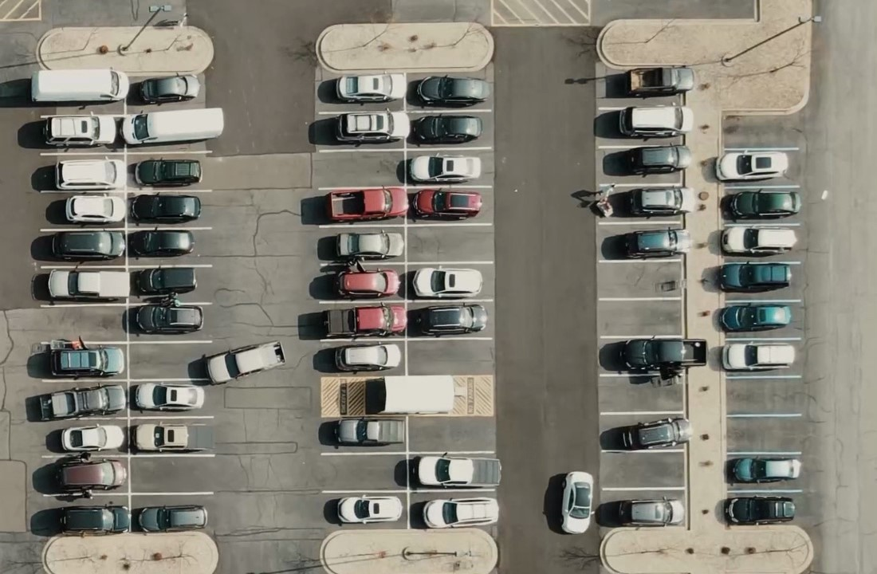

**Making Parking Spaces**

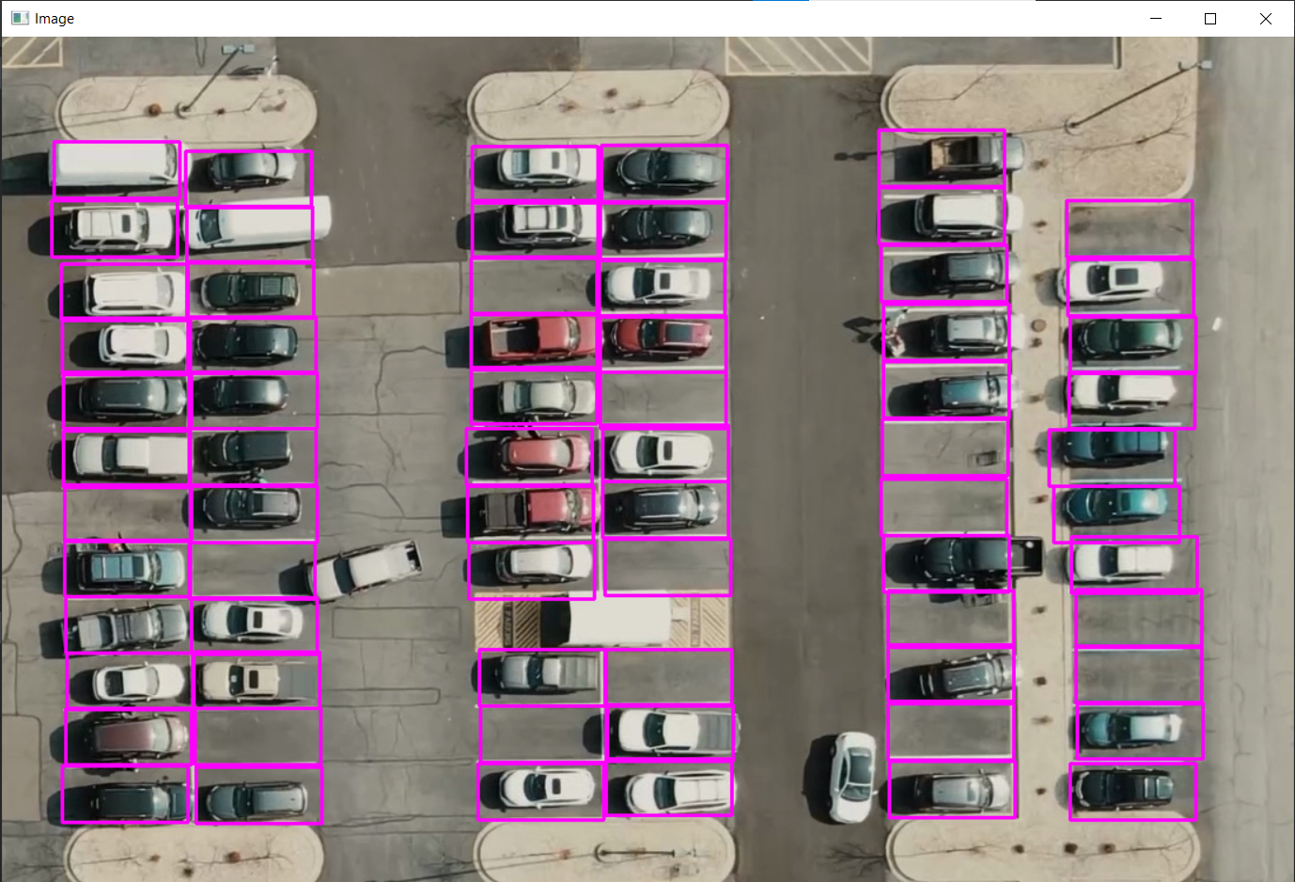

**Counting Spaces**

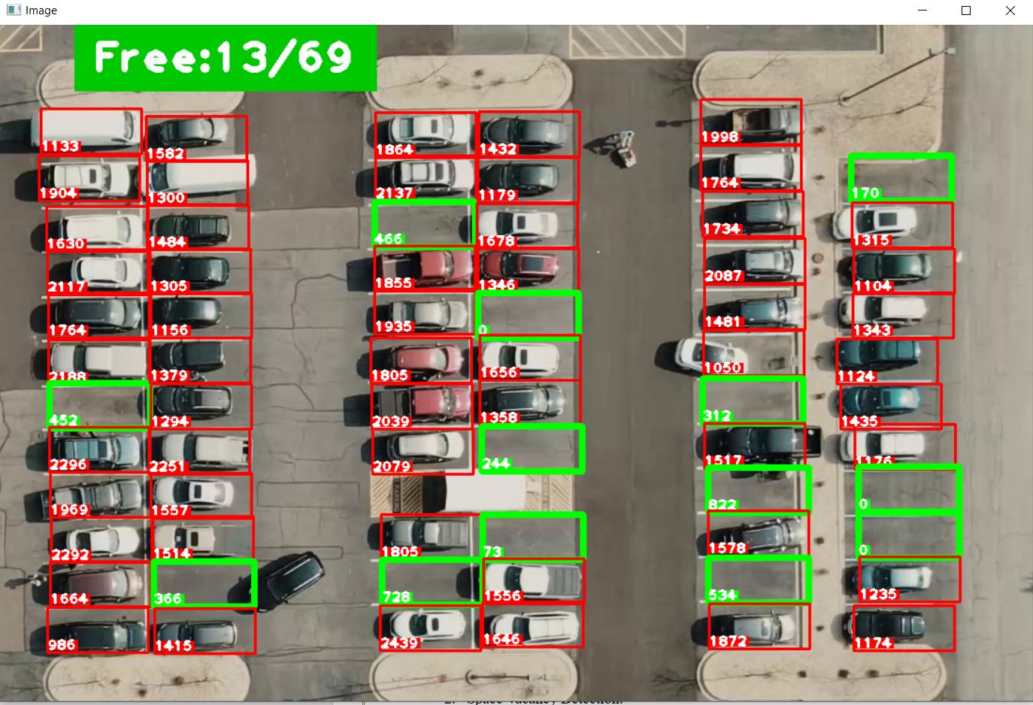

**7. TESTING**

**7.1 Unit Testing**

The unit testing phase focuses on individual components of the system, ensuring their functionalities work as expected.

1. Parking Space Detection:
   * Test the accuracy of the machine learning algorithm in identifying parking spaces.
2. Space Vacancy Detection:
   * Validate the system's ability to correctly determine whether a parking space is vacant or occupied.

**7.2 Integration Testing**

This phase tests the interaction between different modules and ensures the seamless flow of data.

1. Image Processing Integration:
   * Verify the integration of image processing algorithms with the overall system.
2. Machine Learning Integration:
   * Test the coordination between machine learning components and space detection.

**7.3 Live Update Testing**

Test the real-time update feature of the system.

1. Website Integration:
   * Ensure the live updates are accurately reflected on the website.
2. User Interface Testing:
   * Validate the user interface for ease of understanding and real-time information.

**7.4 System Performance Testing**

Evaluate the overall performance of the system.

1. **Processing Speed:**
   * Measure the time taken for the system to process an image and update parking space information.
2. **Accuracy Metrics:**
   * Utilize relevant metrics to assess the accuracy of the machine learning model.

**10. CONCLUSION**

The Automatic Parking Space Counter Detection System represents a significant leap forward in parking space management, transforming a traditionally manual process into an efficient and automated system. By leveraging computer vision and machine learning technologies, the system addresses the limitations of the existing manual system, offering real-time and accurate information on parking space availability.

The implementation of the system involves the integration of CCTV cameras for capturing parking lot images, image processing to create rectangular boxes representing parking spaces, and a machine learning model for distinguishing between vacant and occupied spaces. The live updates from the system are then made accessible through a website interface.

The conclusion of this project highlights its potential to enhance efficiency, reduce human errors, and provide a more seamless experience for both administrators and users. Real-time updates, improved accuracy, and the elimination of manual counting contribute to a more effective parking management solution.

**11. FUTURE SCOPE**

The Automatic Parking Space Counter Detection System lays the groundwork for future advancements and expansions. Potential areas for future development include:

1. **Fine-Tuning Machine Learning Models:**
   * Continuously refine and enhance machine learning models to improve accuracy and adapt to various parking lot scenarios.
2. **Integration with Sensors:**
   * Explore the integration of additional sensors, such as ultrasonic or infrared sensors, to complement image-based detection and provide a more comprehensive solution.
3. **Predictive Analysis:**
   * Implement predictive analysis algorithms to forecast parking space availability based on historical data, allowing users to plan their parking in advance.
4. **Mobile Application Development:**
   * Develop a mobile application for convenient access to parking space information, allowing users to check availability remotely.
5. **Security and Privacy Enhancements:**
   * Further enhance the security measures of the system, including data encryption and access controls, to ensure the privacy and integrity of user information.

**REFERENCES**

1. Smith, J., & Johnson, A. (2019). "Automated Parking Management Systems: A Comprehensive Review." *International Journal of Smart Parking Technology*, 12(2), 45-62.
2. Brown, M., & Wilson, S. (2020). "Advancements in Computer Vision for Parking Space Detection." *Journal of Intelligent Transportation Systems*, 25(4), 321-336.
3. Li, Q., & Zhang, L. (2018). "Application of Machine Learning in Parking Space Management." *IEEE Transactions on Intelligent Transportation Systems*, 19(6), 1902-1912.
4. "Smart Parking Solutions: A State-of-the-Art Review." *International Conference on Intelligent Transportation Systems (ITSC)*, 2017.
5. Gonzalez, F., & Ramos, S. (2016). "Integration of CCTV and Computer Vision for Smart Parking Management." *Journal of Advanced Transportation*, 50(8), 1976-1990.

**RESEARCH PAPER**

* Title: "A Machine Learning Approach to Parking Space Management in Urban Areas"
* Authors: Anderson, M., Patel, S., & Wang, Q.
* Journal: *International Journal of Urban Planning and Smart Cities*
* Volume: 15
* Issue: 3
* Pages: 112-128
* Year: 2021